Oliver Lawrenz
Dipl. Wirtsch.-Inf. (Univ)
Am Gangsteig 10, 83607 Holzkirchen
Mobile: +49 (0)160 – 90962861
e-mail: Oliver.L@wrenz.de
Date of Birth: April 1st, 1968 Nationality: German

Carreer Objective
A full-time position as a director of a department or team in the area of supply chain, procurement, purchasing or inbound / outbound supply chain where I can demonstrate my conceptual, executive and leading skills and contribute to the company. Alternatively program management of supply chain projects, process optimization, change management or production - with or without IT focus.
Summary of Qualifications
- Supply Chain Management  - Procurement  - Material flow  - MRP planning  - Business development  - Sales, cold calling  - Account management  - Commodity strategies  - Purchasing controlling  - Business Process outsourcing | - Program management  - Project lead  - Process modeling  - Change management  - Process and IT specifications  - B2B integration, EDI  - Portals  - International IT roll-outs  - Asian exposure | - SAP logistics (MM, PP, SD)  - SAP SCM  - SAP SRM  - SAP CRM  - IT architecture  - SAP Workflow  - SAP ABAP/4  - Databases, data warehouse  - Programming  - Master Data Management
Achievements
- nomination for BME´s innovation award | 2008
- publications:  - Multiple articles in management journals and books  - Author of 2 books „Supply Chain Management“ and „eProcurement” | 2000, 2001
- Speaker in multiple conferences and seminars | 1997-2008
- Lecturer: Electronic Commerce at Fachhochschule Ludwigshafen | 1998-2000
Work history
2004 – current | Qimonda AG, Munich  Director Purchasing: Strategies, Processes, SRM Technologies
2004 | BearingPoint Global Service Delivery, Munich  Manager SRM
2001 - 2004 | CIBER Deutschland GmbH  General Manager (Sales and Consulting)
2000 – 2001 | EBS Holding AG, Cologne (Metro group)  Executive Vice President B2B Technologies
1997 – 2000 | ORDO Unternehmensberatung GmbH, Walldorf  Head of Business Development and Senior Consultant
1995 – 1997 | ORGA GmbH, Karlsruhe  SAP Consultant, R/3 Implementation and R/3 Roll-outs

Career and job description in more detail

30.11.2004 – current | Infineon Technologies AG, München  became Qimonda AG, Munich (since 01.05.2006)
Company: | Global DRAM producer
Function: | Director (strategic Projects, Processes and SRM Technologies)  reporting line: CPO (Chief Purchasing Officer)
Responsibility: | Globally responsible for purchase processes, guidelines and methods and SRM technologies
Achievements: | - Re-organization of purchasing departments and processes after a 30% headcount reduction program  - Project lead of board initiative: Optimization of Qimonda´s Inbound Supply Chain as part of a global supply chain optimization program:  the project changed production into more customer oriented business: affected areas: forecasting, material planning, supplier integration (EDI and Web-Portal), inventory management, consignment, batch handling.  - nominated for German’s BME Innovation award 2008  - Reengineering of material planning process and algorithms  - Implementation and adoption of an Automotive Best Practice solution: forecast driven ordering: EDI (DELFOR)  - Concept for supplier constraints models  - Reduction of inventory of 45%, reduction of supplier’s planed delivery time of ~50%  - Business Process Outsourcing:  - Implementation of Business Process Outsourcing for spot buy (one time buy)  - Implementation of Catalog Buying incl. Integration into e-markets and outsourcing of content management and price negotiation  - Global Project lead for the process und IT carve-out of Infineon in the area of purchasing systems and processes  - Implementation of Low Cost Country Sourcing processes  - Implementation of Infineon’s Global Supplier Information Portal  - Re-Engineering of supplier evaluation system  - Implementation of 2 Data Warehouses und automatization of management reporting (therein global implementation of DUNS Numbers)  - Implementation of a global spare parts database  - Definition of a global SAP Template for Master Data Server and first standardization in purchase-to-pay process

2004: BearingPoint Global Service Delivery, Munich
Company: | International Consulting  formally known as KPMG Consulting
Function: | Manager (SRM)
Responsibility: | Manage SRM consulting business  Responsible for SAP and SRM Roll-outs
Achievements: | Acquisition of new customers (Tenneco) and up-selling / account management in the area of SRM Infineon und BASF.  Tenneco: Definition of an Auction and RFQ guideline for the sales department.  market overview, basics of game theory, code of conduct  BASF AG: Implementation of a catalog for part with technical specification and classification. Integration into an e-market, Content Management  Infineon AG: Definition of a global SRM Roadmap consisting of Catalog Buying (click2procure/Siemens), Contract Archive, global Contract Server, RFQ and auctions, supplier integration (EDI & RosettaNet), supplier self service and eQuestionnaire, supply base and supplier information module for buyers, master data management (suppliers (DUNS) and sourcing data materials, price lists, order books, shares), SAP R/3 process optimization (esp. contracts), conception of two parallel purchasing Data Warehouses (SAP Business Warehouse und Softcon)

2001 – 2004: CIBER Deutschland GmbH, Cologne
Company: | CIBER Germany. Consulting and solution provider in the field of e-Business and SAP and e-Business  CIBER Germany: 100 % subsidiary of CIBER Inc., a leading IT-Service provider with 6.000 consultants and 60 offices in the USA
Function: | General Manager (Consulting & Sales), Head of Consulting
Responsibility: | set-up CIBER Germany: Consulting Practice
Achievements: | - important customers:  - e-Procurement customers:  Porsche (RFQ and pilot catalog buying),  Siemens SPLS (implementation, content providing),  Veba Oil (concept and coaching Roll-out EBP),  Deutsche Bahn (optimizing material flow „Tools“),  ThyssenKruppStahl (eRFx),  dalli-Werke (Prokect planning/coaching e-Procurement),  Bank für Sozialwirtschaft (Ramp-on e-market),  - Data-Warehouse customer: SUKI International  - CRM-customer: Deutscher Sparkassenverlag  implementation CRM, integration to a inter-company B2B Portal, integration of several e-shops to a virtual multi company e-shop  - SAP consulting for DaimlerChrysler, Kärcher, Unilever, Mekkafood, 3M  - e-Procurement customer: savings of 40% (process costs) and 10 – 25 % material costs  - Sales and business development partnership with Siemens SPLS: first customer with Porsche: e-procurement implementation and ramp-on to click2procure (Siemens e-market)  - Sales and business development partnership with WestLB:  Development of e-Services/Web-Service for the WestLB-marketplace. first industrial pilots  - Concept & launch of CIBER CRM Portals for joint use.  - Design of methods and tools for the German market  (ROI, Cost Benefit Analysis, Scorecards).

2000 – 2001: EBS Holding AG, Cologne (Metro-Group)
Company: | EBS Holding AG is the B2B e-Business Holding of Metro  subsidiaries of EBS Holding AG:  TellSell, Pago, omnis-online, primus-online, e-market Factory
Function: | member of the management  Executive Vice President „B2B-Technologies“  Head of Field Operation
Responsibility: | Set-up: „e-market factory“ as an „e-Service Provider“ in the field of e-Fulfillment (e-finance, e-logistics, e-insurance).  Offering: implementation services and Web-Services for international e-Procurement-customers und-systems/platforms.  Offering of fully automated fulfillment services in cooperation with leading fulfillment logistics, finance & insurance partner. Web-Services for e-procurement and e-market customers, such as escrow, transport insurances, credit rating companies, etc.
Achievements: | - Creation of Business Model and Business Plan and approval by Metro board of directors  - Global Players as investors such as:  - CommerceOne (Palo Alto. London),  - Hewlett Packard (Palo Alto),  - Citibank (New York),  - SwissCom (Zürich)  - Technology partnership with Hewlett Packard, CommerceOne: Prototype and proof of concept. Implementation of Web-Services / e-Services  - Business Development partnership with KPMG and implementation partnership for first pilots with GFT  - Fulfillment partnership with leading logistics, finance and insurance partners such as Schenker, AON, Citibank

1997 – 2000: ORDO Unternehmensberatung GmbH, Walldorf
Company: | International SAP Logo-Partner
Function: | Management consultant & senior consultant SAP R/3 Logistics  pre-sales consultant  Head of Business Development “Electronic Commerce”
Responsibility: | International SAP projects in Europe  Set-up ORDO “e-Commerce Lab” in SAP Partnerport, Walldorf
Achievements: | - Project manager of an European SAP roll-out at Freudenberg. (SD, MM, PP).  In-time & budget. Implementation of an inter-plant MRP and procurement with SAP R/3 standard functions. Increase of delivery reliability up to 95%. Speed-up of internal procurement and material flow of 25%. duration of the roll-out project: 18 months  - Specification, design and development of a ORDO product „e-Transactors“: first pilots in the field of inter-plant material requirement planning and procurement  - Technology partnership with Seeburger, Fijutsu Siemens and SAP AG in the field of EAI and Supply Chain. Today’s functions of the e-transactor can be found in SAP’s Business Connector as well as in WAS/NetWeaver.  - Effective escalation management on behalf of SAP AG, Walldorf for Eletricity Authority of Cyprus (national electric utility of Cyprus)  - Project coach of internal project manager: Real Estate Management implementation project at Deutschen Post Immobilienservice. Creation of e-Procurement strategy for Deutschen Post Immobilienservice  - Business process optimization and documentation for the SAP roll-out project at Lufthansa  - Aautomated invoice verification (EDI/IDOC) at Douglas  - Development of a business process compliant knowledge database for re-use of consulting know-how, cook-books, etc.

1995 – 1997: ORGA GmbH, Karlsruhe
Company: | Leading SAP-solution provider and outsourcing vendor
Function: | Application consulting SAP R/3 Logistics,  1996 senior SAP consultant  Pre-sales consultant
Responsibility: | SAP implementation and customizing, project management, business process optimizing
Achievement: | - Project manager of SAP SD sub-project. Pilot SAP R/3 implementation of Wacker Chemicals. big bang implementation, roll-out and optimization. In-time & budget (18 months), assembly management, configuration, bill-of-materials, sales & operation management, material requirement management, PP-controlling and SAP-workflow  - Yearly cost savings 250.000 DM of due to automated workflow-based assembly management process  - Project member of a SAP industrial solutions development team plant construction (configuration of bill-of-materials in sales and production)  - Increase of average value of plant order by 200% due to optimizations in production planning, sales & operation planning (demand forecast)

Education
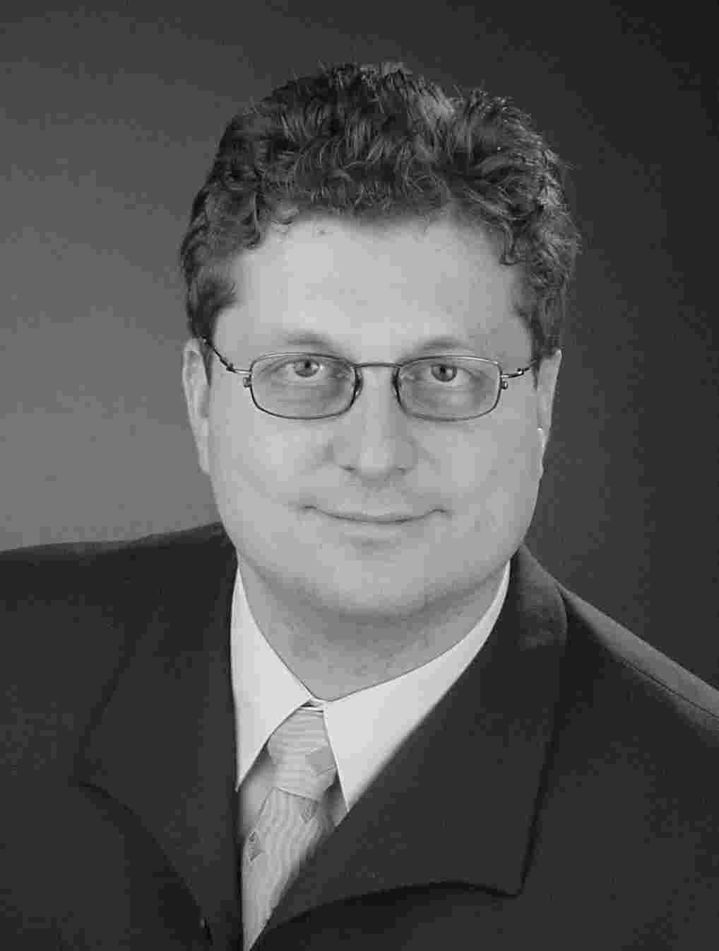
(chronological)

School/college
1974 – 1978 | Evangelische Grundschule Ergste
1978 – 1987 | Ruhrtalgymnasium Schwerte,  Abiturschnitt: 2,1

Military Service
01.07.1987 - 30.09.1988 | 2. Beobachtungsbataillon 63, Itzehoe

University
01.11.1988 - 30.06.1990 | Otto-Friedrich-Universität Bamberg, Management Science and Computer Science (Vordiplom: „gut")
01.10.1990 - 30.06.1991 | Intercalary year abroad:  University College of Swansea, Wales, UK:  Artificial Intelligence, Information, Management, Financial Services
01.11.1991- 30.05.1995 | continuation of studies
University degree | Degree Dipl. Wirtsch.-Informatiker grade (2,0)
1990, 1991 | elected member of Fachschaft SoWi & „Studentischer Konvent"

Self-employment (during studies)
Self employed | - Formation of GIV (Gesellschaft für Informationsverarbeitung) as a parallel operation to studies  - Organization of international conferences for GMO, Sales and strategy consulting for Hewlett Packard, ORGA GmbH and Input Ltd (market research)
Internships | - Hoesch AG (finance consolidation software IBM 3090)  - Deutsche Nickel-Werke (EDP department: SAP, COBOL)  - Siemens AG, KWU Erlangen, Programming PROLOG  - Chairs: Prof Augsburger, Prof. Gabele und Prof. Sinz

Special skills and experience

Technical skills: | SAP Moduls:  - Sales and distribution (SD),  - Materials management (MM),  - Production planning (PP)  - Advance Optimizer and Planner (APO)  Methods:  - Data Modeling DDIC,  - Business Object Repository BOR,  - Business process modeling (ARIS)  Basis:  - ABAP Programming  (Batch Input, Migration, Interfaces, User Exits)  - SAP-Workflow  MS office WORD, Excel and Access
Management: | - 7 Habits of highly effective people  - Insights Discovery
Languages: | - English: business fluent (spoken/written)  - Intercalary year abroad (Wales) during studies,  annual examinations, English Proficiency  - Supply Chain Project in Malaysia and supplier negotiations  - International SAP-Projects in Norway, Finland, Sweden, Denmark and Cyprus  - Investor negotiations in USA and U.K.  - Basics in French (2 years) and Spanish (4 years)
Interests: | Travel, Sailing, Cooking, Music (cello/piano), Chess

